**Ideation Phase**

Define the Problem Statements

|  |  |
| --- | --- |
| Date | 10th October 2022 |
| Team ID | PNT2022TMID33205 |
| Project Name | Project - Digital Naturalist - AI Enabled tool for Biodiversity Researchers |
| Maximum Marks | 2 Marks |

**Customer Problem Statement :**

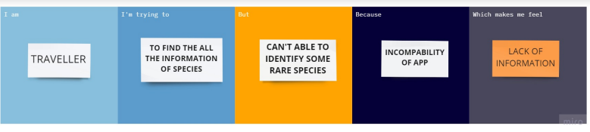

|  |  |  |  |  |  |
| --- | --- | --- | --- | --- | --- |
| **Problem Statement (PS)** | **I am (Customer)** | **I’m trying to** | **But** | **Because** | **Which makes me feel** |
| PS-1 | Students | Use in every corner of the country | In Rural areas I can’t able to access | Network issues | It can be Offline |
| PS-2 | Reseachers | Research on plants for medicine purpose | Can’t able to  Research  the plant | Lack of information | Dissatisfied |